Databases Group Project

Team: Можаров Егор, Васильев Борис, Дрягин Артём, Гюрсой Александр-Эфе (DSBA-192)

Оглавление

Project description 3

Technical requirements 3

Functional dependencies 3

Data restrictions 4

Preliminary database schema 4

Reasons for Normalization 4

Database Creation 5

Quires for DB 7

Conclusion 10

# Project description

In this project, our team implemented a trading platform database. It displays information on all orders placed, customer information, product statuses and characteristics, as well as information about postomats (their location and status)

# Technical requirements

1. Client information
   1. User registration
   2. User authorization
2. Order information
   1. Make an order
   2. Watch information about order
   3. Decline order
3. Item information
   1. Watch information about order
   2. Calculate total profit from items
4. Postomat information
   1. Watch information about postomat
   2. Reserve postomat for order

# Functional dependencies

Client: **Client-ID**->Name, Surname, Country, City, Address, Mail, Password, Login, Date-Registration

Order: **Purchase -ID**->Purchase-status, Client-ID, Date-Registration, Postomat-ID, Date-Finish, Date-Accept, Date-Decline

Postomat: **Postomat-ID**->Status

Item: **Item-ID**->Order-ID, Item-Status, Item-Type, Name, Price

Oreder_status **id**->Status

Postomat_location: **id**->Country, Address, City, id

Item_Status: **id**-> Status

Item_Type: **id**-> Type

# Data restrictions

* Each client can make more than 0 orders
* Each item has only 1 status and only 1 type
* Each order can change status during the process delivering
* Each postomat can change status but in moment can have only one status
* Each postomat can have only one location and cannot change it

# Preliminary database schema

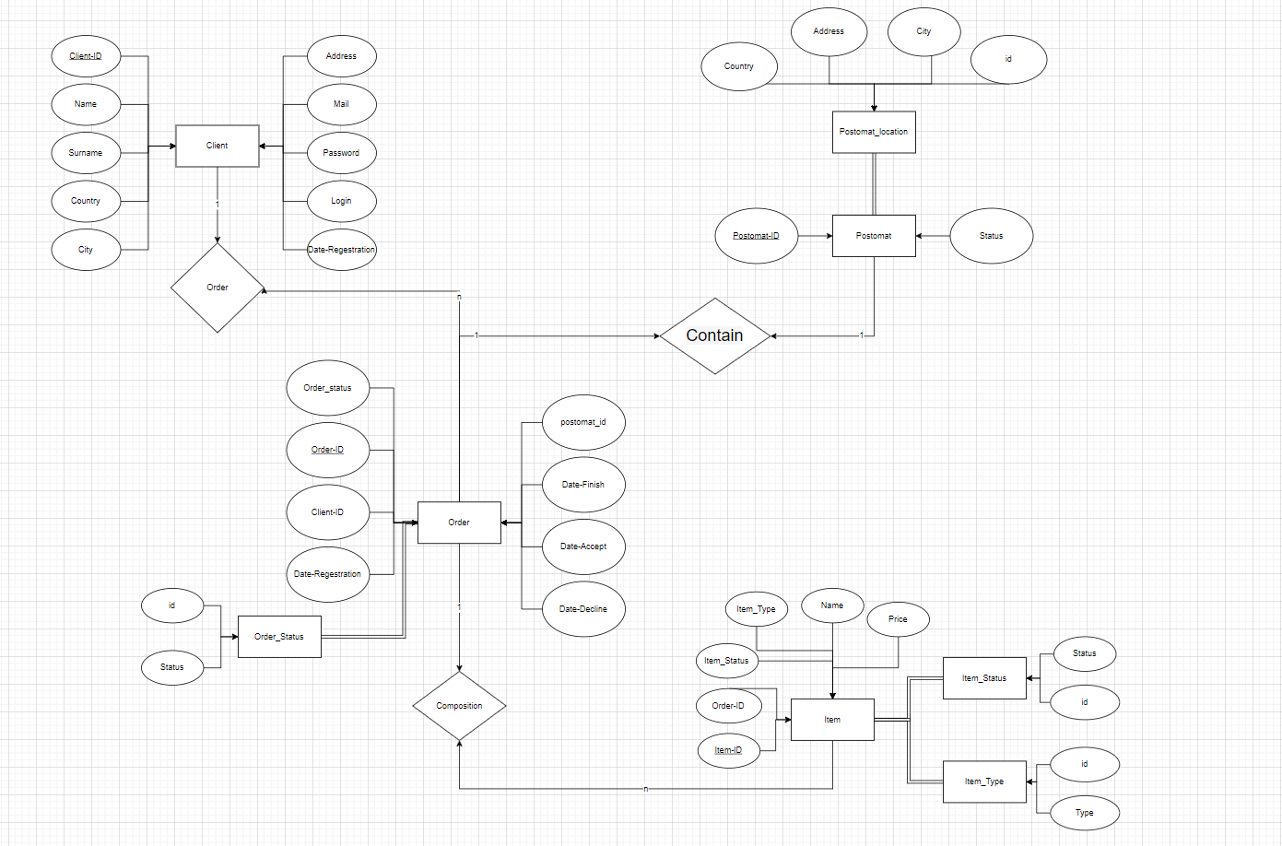

# Reasons for Normalization

Normalization itself is needed for more convenient structuring of data, as well as their preservation. In our case, if we want to delete an order by order-id, then we will not delete the information on our client, otherwise, when storing all the information in one place, the client's personal data could suffer. In addition, when using normalization, we avoid the problem of data redundancy. In addition to the actual advantages, we can include such positive aspects as the acceleration of queries due to a more uniform distribution of data, more convenient storage of the data itself in terms of access to them

# Database Creation

CREATE TABLE IF NOT EXISTS Client(

Client_ID int AUTO_INCREMENT NOT NULL PRIMARY KEY,

Name VARCHAR(255) NOT NULL,

Surname VARCHAR(255) NOT NULL,

Country VARCHAR(255) NOT NULL,

City VARCHAR(255) NOT NULL,

Address VARCHAR(255) NOT NULL,

Mail VARCHAR(255) NOT NULL,

Password VARCHAR(255) NOT NULL,

Login VARCHAR(255) NOT NULL,

Date_Regestration DATE NOT NULL

);

CREATE TABLE IF NOT EXISTS Purchase(

Purchase_ID int AUTO_INCREMENT NOT NULL PRIMARY KEY,

Status_ID INT REFERENCES Purchase_Status(id) On DELETE CASCADE NOT NULL,

Client_ID INT NOT NULL,

Postomat_ID INT,

Date_Regestration DATE NOT NULL,

Date_Finish DATE,

Date_Accept DATE,

Date_Decline DATE

);

CREATE TABLE IF NOT EXISTS Purchase_Status(

id INT AUTO_INCREMENT NOT NULL PRIMARY KEY,

Status VARCHAR(255) NOT NULL

);

CREATE TABLE IF NOT EXISTS Item(

Item_ID INT NOT NULL PRIMARY KEY,

Purchase_ID INT REFERENCES Purchase(Purchase_ID) On DELETE CASCADE,

Item_Status INT REFERENCES Item_Status(id) On DELETE CASCADE NOT NULL,

Item_Type INT REFERENCES Item_Type(id) On DELETE CASCADE NOT NULL,

Name VARCHAR(255) NOT NULL,

Price INT NOT NULL

);

CREATE TABLE IF NOT EXISTS Item_Status(

id INT AUTO_INCREMENT NOT NULL PRIMARY KEY,

Status VARCHAR(255) NOT NULL

);

CREATE TABLE IF NOT EXISTS Item_Type(

id INT AUTO_INCREMENT NOT NULL PRIMARY KEY,

Type VARCHAR(255) NOT NULL

);

CREATE TABLE IF NOT EXISTS Postomat(

Postomat_ID INT AUTO_INCREMENT NOT NULL PRIMARY KEY,

Postomat_location REFERENCES Postomat_Location(id) On DELETE CASCADE NOT NULL,

Status VARCHAR(255) NOT NULL

);

CREATE TABLE IF NOT EXISTS Postomat_Location(

id INT AUTO_INCREMENT NOT NULL PRIMARY KEY,

Country VARCHAR(255) NOT NULL,

City VARCHAR(255) NOT NULL,

Address VARCHAR(255) NOT NULL

);

# Quires for DB

**--Adding new values to Client**

INSERT INTO Client VALUES(1, "Egor", "Mozharov", "Russia", "Moscow", "Nelidovskya 23", "egor.mozharov@mail.ru", "Egor134", "Egor123", "2020-10-10");

SELECT * from Client;

**--Adding new values to Purchase**

INSERT INTO Purchase VALUES(1, 1, 1, 1, "2020-10-15", "2020-11-14", "2020-10-15", NULL);

SELECT * from Purchase;

**--Adding new values to Purchase_Status**

INSERT INTO Purchase_Status VALUES(1, "Delivered");

SELECT * from Purchase_Status;

**--Adding new values to Item**

INSERT INTO Item VALUES(1, 1, 1, 1, "AiphoneX", 7000);

INSERT INTO Item VALUES(2, NULL, 2, 1, "AiphoneX", 5000);

INSERT INTO Item VALUES(3, 1, 1, 1, "AiphoneX", 7000);

SELECT * from Item;

**--Adding new values to Item_Status**

INSERT INTO Item_Status VALUES(1, "Sold");

INSERT INTO Item_Status VALUES(2, "Warehouse");

SELECT * from Item_Status;

**--Adding new values to Item_Type**

INSERT INTO Item_Type VALUES(1, "Electronic Device");

SELECT * from Item_Type;

**--Adding new values to Postomat**

INSERT INTO Postomat VALUES(1, 1, "Work");

SELECT * from Postomat;

**--Adding new values to Postomat_Location**

INSERT INTO Postomat_Location VALUES(1, "Russia", "Moscow", "Nelidiv 25A");

SELECT * from Postomat_Location;

**--Update Item_Type table**

UPDATE Item_Type SET Type = 'Phone' WHERE id = 1;

SELECT * from Item_Type;

**--Update Client table**

UPDATE Client SET Address = 'Nelo 12' WHERE Name = 'Egor' and Surname = 'Mozharov';

SELECT * from Client;

**--Update Postomat table**

UPDATE Postomat SET status = "Broken" WHERE Postomat_ID = 2;

SELECT * from Postomat;

**--Delete Item with id=2**

DELETE FROM Item WHERE item_id = 2;

SELECT * from Item

**--Select all Purchase which was delivered and amount of Item in one Purchase more than 1**

SELECT * FROm Purchase LEFT JOIN Item ON Item.purchase_id = Purchase.purchase_id GROUP BY Purchase.purchase_id HAVING COUNT(Item.Item_ID) >= 2;

**--CalculatePostomat_Location total Price for item which was sold**

SELECT SUM(Item.Price) FROM Item LEFT JOIN Item_Status ON Item_Status.id = Item.Item_Status WHERE Item_Status.Status = "Sold"

**--Calculate current number of working postomats**

SELECT COUNT(Postomat.Postomat_ID) FROM Postomat WHERE Postomat.Status = "Work"

**--Calculate how much the clients living in Moscow spent in total**

SELECT SUM(Item.Price) FROM Item

FULL JOIN Item_Status ON Item_Status.id = Item.Item_Status

FULL JOIN Purchase ON Purchase.purchase_id = Item.Purchase_ID

FULL JOIN Client ON Client.client_id = Purchase.Client_ID

WHERE Item_Status.Status = "Sold" AND Client.City = "Moscow"

**--Select all distinct Purchase_Status**

SELECT DISTINCT(Purchase_Status.Status) FROM Purchase_Status

**--Calculate the number of Client who made at least 1 purchase**

SELECT COUNT(Client.Client_ID) FROM Client

CROSS JOIN Purchase ON Purchase.Client_ID = Client.Client_ID

# Conclusion

During the execution of the project work, our team managed to fulfill all the tasks assigned to us, namely: Normalization, Technical requirements, Preliminary database schema, Functional dependencies, create database and make queries for it. Moreover, teamwork was worked out, the division of responsibilities was improved, practical skills were improved when writing queries, as well as the types of normalization were studied in more detail, as well as the ways and reasons for its application.

Source code: [Github](https://github.com/EgorMozharov/HW_DB_Group_Project)